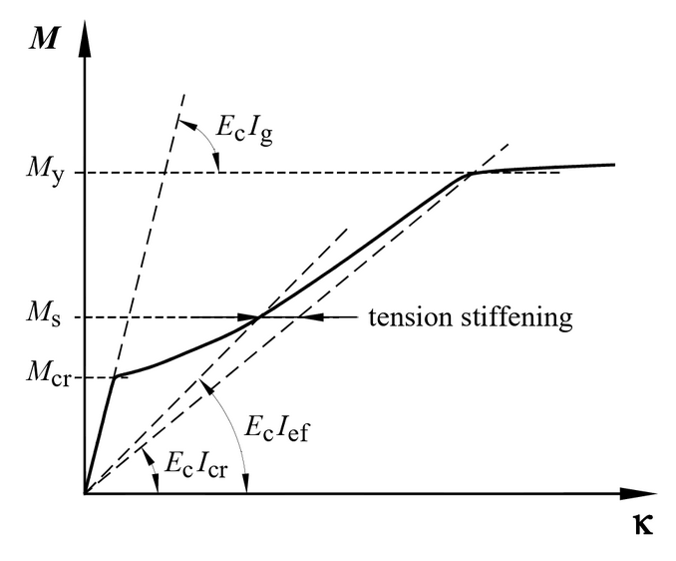

1. preliminary sizing of beams

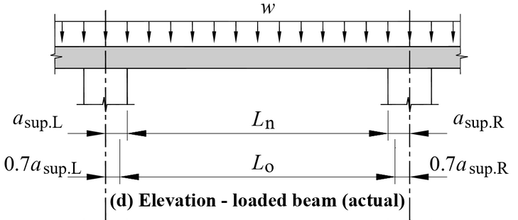

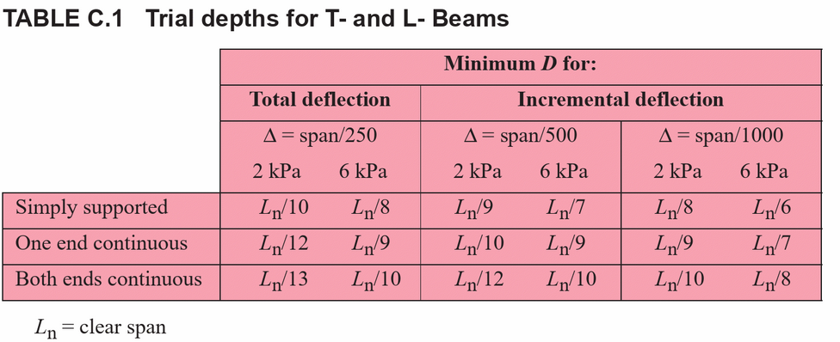

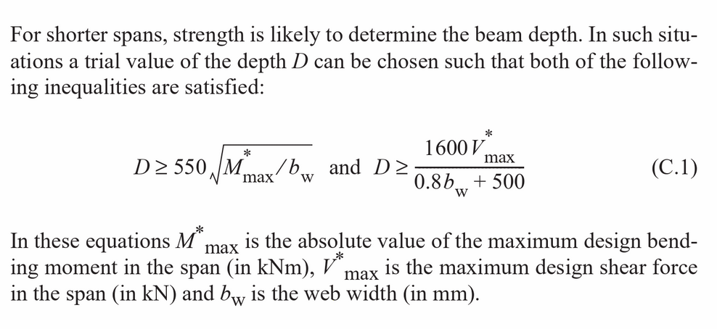

Crack limits

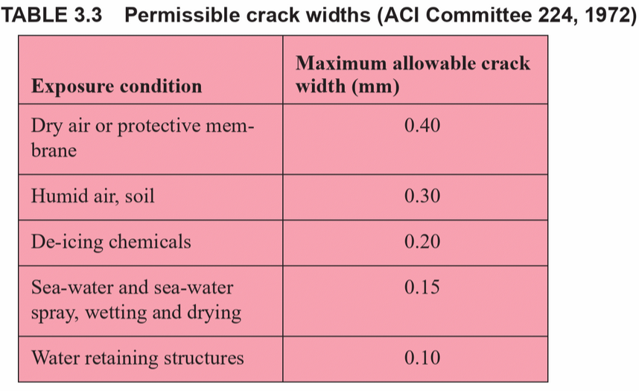

Flexural strength

1. the stress block is given by and the relevant equations in Section 8.1.3 of AS5100.5. The limiting strain is (clause a d of Section 8.1.3).

The compressive force in the concrete is where . (Section 8.1.5).

Design areas for reinforcing bars 